
Department of Electrical Engineering and Computing
3rd year 2nd Semester POWER & CONTROL ENGINEERING
Introduction to Control Systems (PCE3204)
Assignment

Date: 28/06/2019. Max.Marks:
________________________________________________________________

Q1. The open loop transfer function of an unity feedback control system is given by
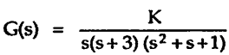
Determine the value of K that will cause marginally stable and also find the frequency of oscillations.
- Using Routh’s method
- Draw the root locus diagram and determine K the system will be marginal stable and the frequency of oscillations.
Q2. Using Routh’s method, check the stability of
Q3. Given the open loop transfer function, determine the range of K so that the closed loop system is stable
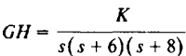
1. Using Routh’s method
2. Draw the root locus diagram and determine the range of K so that the closed loop system is stable
Q4. The Unit-step Response of a second order system is given as
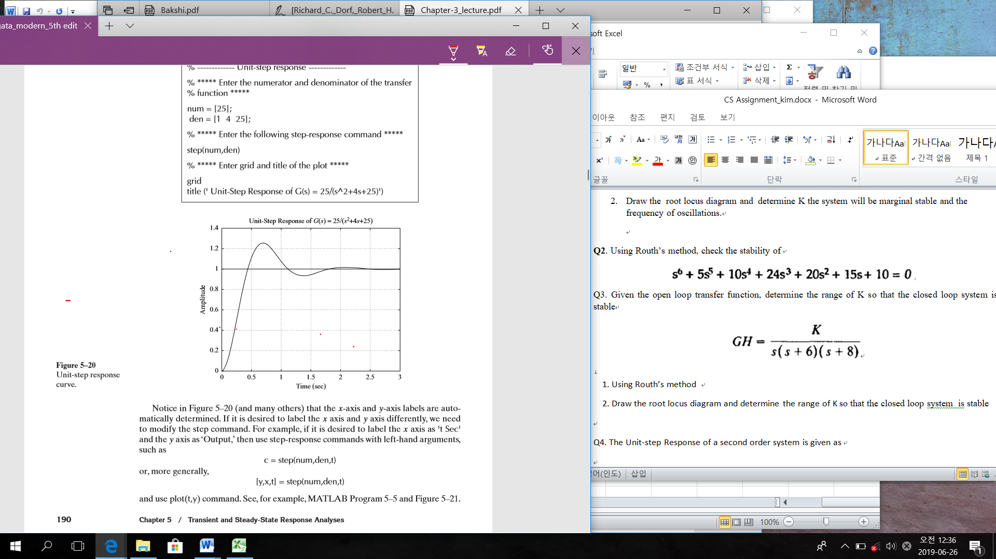
Estimate the following using the response,
- The damped natural frequency
- The damping ratio
- The undamped natural frequency

- __ The End __

